TRON

‘My Smart Ride’

Kumar Saurabh, Edward Philon,

Lyle Sherman, Madison Majeed,

Soehl Knkade, Ayesha Syed

Table of Contents

1. Introduction 3

1.1 Purpose 3

1.2 Scope 3

1.3 Definitions, Acronyms and Abbreviations 3

1.4 References 3

1.5 Overview 3

2. Overall Description 4

2.1 Use-Case Model 4

2.2 Data Dictionary 5

2.3 Assumptions and Dependencies 5

3. Specific Requirements 6

3.1 Use-Case Reports 7

3.2 Supplementary Requirements 7

1. Introduction

## Purpose

To develop a mobile app prototype which will enable customers to request for self-driving taxi ride using virtual assistance and make the payment using bitcoin. This will minimize the transportation cost and hidden financial charges.

## Scope

* Identification of Use case
* Build mobile app prototype.

## Definitions, Acronyms and Abbreviation

**VVA -Virtual Voice Assistant**

**BC -Bitcoin**

**SDC - Self-Driving Car**

## References

## IEEE SRS Format.

## TGMC-2008 Sample Synopsis Format.

## Overview

This tool will allow users to easily and efficiently request transportation of

self-driving car. Unlike services such as Uber and Lyft, self-driving cars allow for a

decrease in human error when driving and also allow rides to be selected without

bias. The introduction of bitcoin will also allow users more discretion, elimination

of banking fees, increased security and more mobility.

# Overall Description

## Use-Case

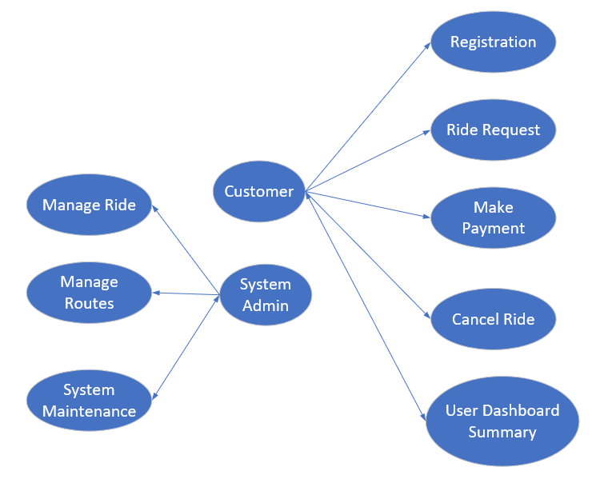

1. Customer: - is responsible for registering with the tool and creating a profile with the company name.
   1. **Registration**
   2. **Ride Booking**
   3. **Make Payment**
   4. **Cancel Ride**
   5. **User Dashboard Summary**
2. System Admin: - is responsible for dealing with all the proceedings of the project.
   1. **Manage Ride**
   2. **Manage Routes**
   3. **System Maintenance**

## Data Dictionary

Example:

|  |  |  |  |  |
| --- | --- | --- | --- | --- |
| Field Name | Data Type | Format | Field Size | Example |
| Location | Text |  | 20 | San Antonio |
| Vehicle | Text |  | 20 | Sedan |

## Assumptions and Dependencies

2.2.1 For this system requirement, it is assumed that all vehicles have been thoroughly tested and meet all safety regulations.

2.2.2 The end-user will have read and agreed to all disclaimers prior to requesting service.

# Specific Requirements

## Use-Case Reports

**Name of Use Case -** User’s Ride Request

**Description –** An app will be created to recognize voice (VVA) of customer by interacting with the software for requesting transportation

**Pre Condition –** The customer must be registered into the system prior to request

**Normal Flow of Events –**

* User gives voice command via given script for testing
* A query will be fired to the database
* Results (output) will populate on user’s mobile device
* A selection will be made by the user to accept/decline ride
* The vehicle software will communicate with mobile device showing map/navigation/location of vehicle/expected arrival time/cost of ride

**Name of Use Case –** User Registration

**Description –** User will need to input personal identifiable information

**Pre Condition**  User must download Application to mobile device prior to setup.

**Normal Flow of Events –**

* User downloads app to mobile device
* User registers in app and agrees to terms and conditions
* User Inputs transaction information
* User configures Virtual Voice Assistant

**Name of Use Case –** Enterprise Data Warehouse

**Description –** An enterprise database management system must be created to capture, store, and transmit data to assigned objects.

**Pre Condition -** Table data must pre-exist, business objects documented (Data Dictionary), storage requirements must be met, Operations support in place and ready

**Normal Flow of Events –**

* Table/Back-End Objects development
* App/Front-End Objects development
* Mapping Requirements
* Technical Specifications
* Data Dictionary Updates
* Peer Reviews
* Dev [Unit Testing/Test [System Testing]/Prod Environment [Validations]
* Operations Process Chain/Support

## Supplementary Requirements

* Since this a tool which can be used from anywhere and anytime in the world, so the server should be well managed for such kind of requirement.
* The users using this and importing the reports from this tool should have supporting software to run them.
* To use the application in the best possible way please read the tips displayed while using the tool.